3/12/2020

**RAIHAN MD RAKIBUL ISLAM**

**2020380029**

**HOME WORK**

**9.3,9.5,9.6,10.1,10.2,10.3(P1)**

9.3

4. List the ordered pairs in the relations on {1, 2, 3, 4} corresponding to these matrices (where the rows and columns correspond to the integers listed in increasing order)

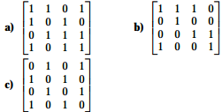

**Ans:**

A) We are interested in the relations on {1,2, 3, 4}. Thus a1 = b1 = 1, a2 = b2 = 2, a3 = b3 = 3, a4 = b4 = 4. Note that only the 1-values in the matrix will represent a tuple that is in the relation. We note that the element m11 is 1, thus (a1, b1) = (1, 1) € R. We note that the element m12 is 1, thus (a1, b2) = (1, 2) € R Similarly, we obtain for all 1-values in the given matrix:

(a1, b4) = (1, 4) € R

(a2, b1) = (2, 1) € R

(a2, b3) = (2, 3) € R

(a3, b2) = (3, 2) € R

(a3, b3) = (3, 3) € R

(a3, b4) = (3, 4) € R

(a4, b1) = (4, 1) € R

(a4, b3) = (4, 3) € R

(a4, b4) = (4, 4) € R

Thus, the relation R then contains all previously found tuples:

R = {(1,1), (1, 2), (1, 4), (2, 1), (2, 3), (3, 2), (3, 3), (3, 4), (4, 1), (4, 3), (4, 4)}

B) We are interested in the relations on {1,2, 3,4}. Thus a1 = b1 = 1, a2 = b2 = 2, a3 = b3 = 3, a4 = b4 = 4. Note that only the 1-values in the matrix will represent a tuple that is in the relation. We note that the element m11 is 1, thus (a1, b1) = (1, 1) € R We note that the element m12 is 1, thus (a1, b2) = (1, 2) € R Similarly, we obtain for all 1-values in the given matrix:

(a1, b3) = (1, 3) € R

(a2, b2) = (2, 2) € R

(a3, b3) = (3, 3) € R

(a3, b4) = (3, 4) € R

(a4, b1) = (4, 1) € R

(a4, b4) = (4, 4) € R

Thus, the relation R then contains all previously found tuples:

R = {(1,1), (1, 2), (1,3), (2, 2), (3, 3), (3, 4), (4, 1), (4, 4)}

C) We are interested in the relations on {1, 2, 3, 4}. Thus a1 = b1 = 1, a2 = b2 = 2, a3 = b3 = 3, a4 = b4 = 4. Note that only the 1-values in the matrix will represent a tuple that is in the relation. We note that the element m12 is 1, thus (a1, b2) = (1, 2) € R We note that the element m14 is 1, thus (a1, b4) = (1, 4) € R Similarly, we obtain for all 1-values in the given matrix:

(a2, b1) = (2, 1) € R

(a2, b3) = (2, 3) € R

(a3, b2) = (3, 2) € R

(a3, b4) = (3, 4) € R

(a4, b1) = (4, 1) € R

(a4, b3) = (4, 3) € R

Thus, the relation R then contains all previously found tuples:

R = {(1,2). (1,4), (2,1), (2, 3), (3, 2), (3,4), (4, 1). (4, 3)}

**14.** Let *R*1 and *R*2 be relations on a set *A* represented by the matrices

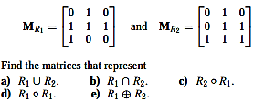

**Ans:**

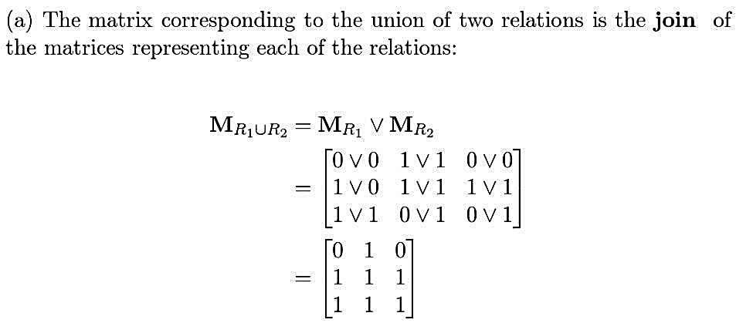

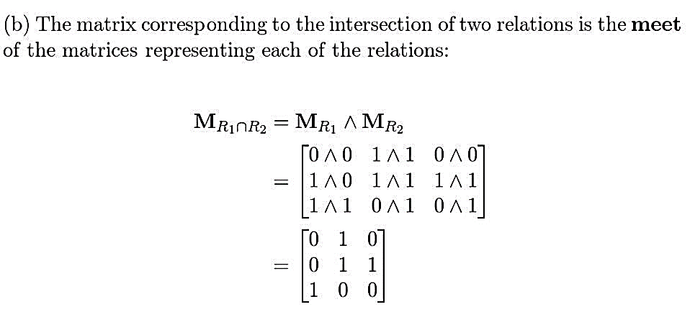

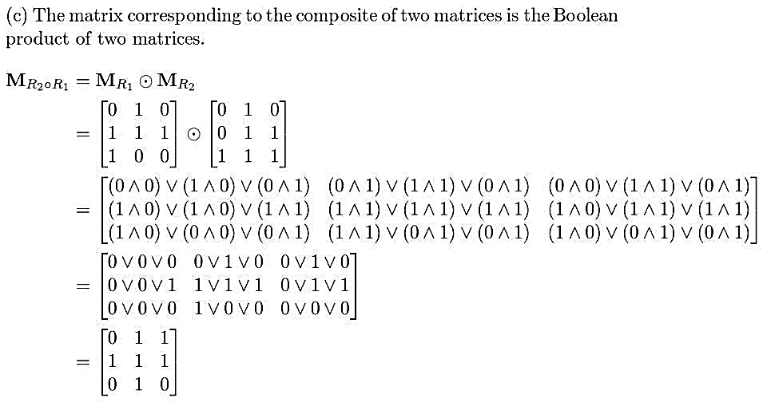

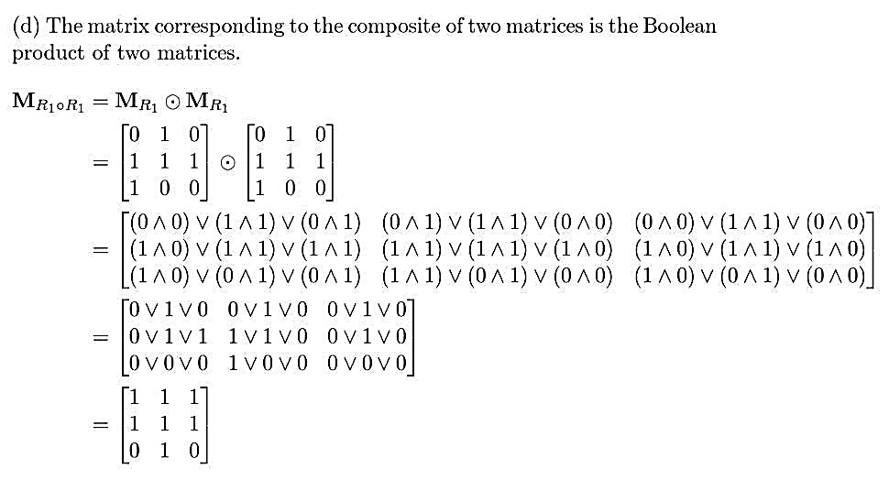

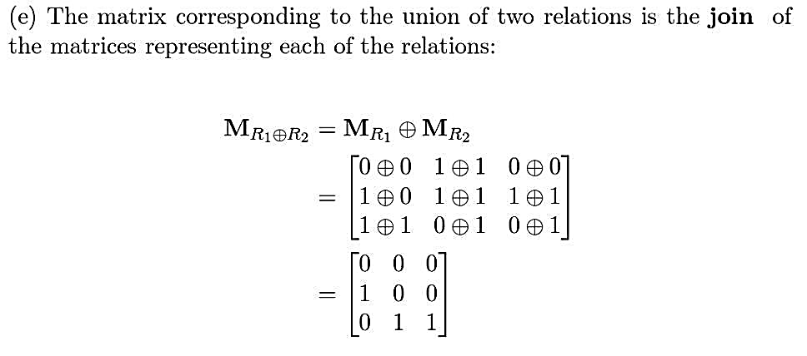

22. Draw the directed graph that represents the relation  
{(a, a), (a, b), (b, c), (c, b), (c, d), (d, a), (d, b)}.

**Ans:**

{(a, a), (a, b), (b, c), (c, b), (e, d), (d, a), (d, b)} We note 4 different values in the ordered pairs: a, b, c, d. Draw 4 points for a, b, c, d respectively. (a, a) is contained in the relation, thus we need to draw an arrow from point a to point a (which forms a loop). (a, b) is contained in the relation, thus we need to draw an arrow from point a to point b. (b, c) is contained in the relation, thus we need to draw an arrow from point b to point c. (c, b) is contained in the relation, thus we need to draw an arrow from point e to point b. (c, d) is contained in the relation, thus we need to draw an arrow from point c to point d. (d, a) is contained in the relation, thus we need to draw an arrow from point d to point a. (d, b) is contained in the relation, thus we need to draw an arrow from point d to point b.

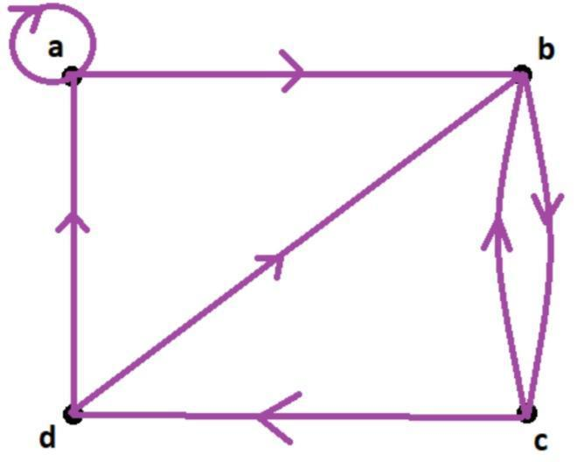

9.5

4. Define three equivalence relations on the set of students in your discrete mathematics class different from the relations discussed in the text. Determine the equivalence classes for each of these equivalence relations

**Ans:**

A = Set of students in your discrete mathematics class

We need to define three equivalence relations. For example:

R1 = {(a, b) |a and b have the same gender}

R2 = {(a, b) |a and b both speak French}

R3 = {(a, b) |a and b live in the same town}.

The equivalence class of a is the set of all elements that are in relation to a.

[a] R1 = {b| b has the same gender as a}

[a] R2 = {b| b speaks French}

[a] R3 = {b| b lives in the same town as a}

24. Determine whether the relations represented by these zero–one matrix are equivalence relations.

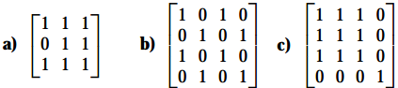

**Ans:**

a)

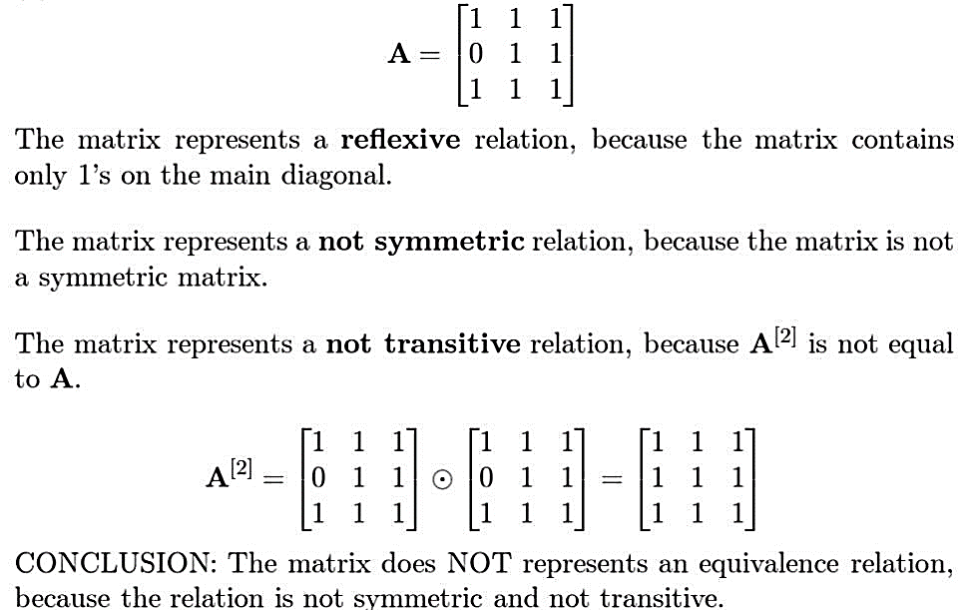

**b)**

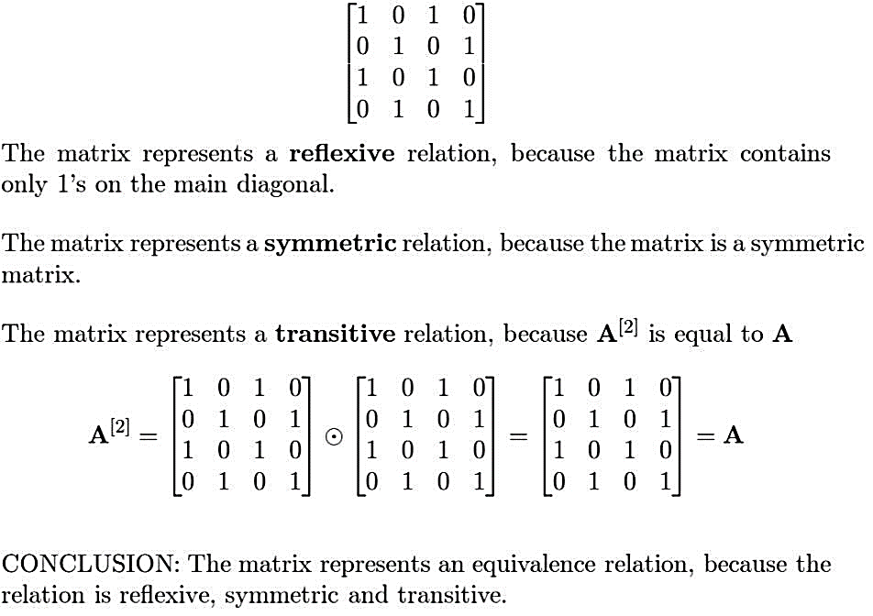

**c)** 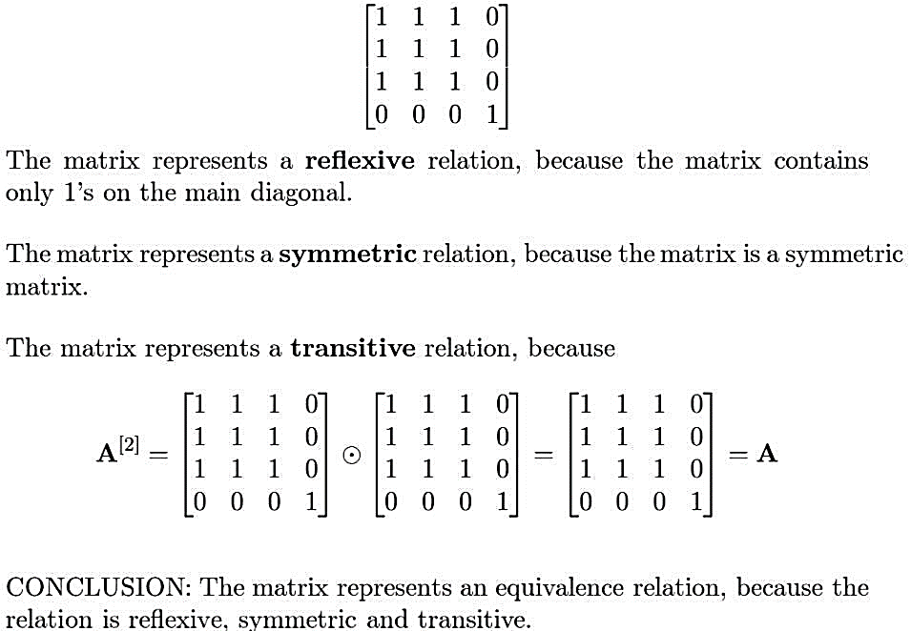

**9.6**

4. Is *(S, R)* a poset if *S* is the set of all people in the world and *(a, b)* ∈ *R*, where *a* and *b* are people, if  
a) *a* is no shorter than *b*?

**Poset**  
b) *a* weigh more than *b*?

**Not a poset**  
c) *a* = *b* or *a* is a descendant of *b*?

**Poset**  
d) *a* and *b* do not have a common friend?

**Not a poset**

6. Which of these are posets?  
a) (R, =) **Yes**

b) (R, <) **No**

c) (R, ≤) **Yes**

d) (R, ≠) **No**

**10.1**

**2.** What kind of graph (from Table 1) can be used to model a highway system between major cities where

**a)** there is an edge between the vertices representing cities if there is an interstate highway between them?

**Simple Graph**

**b)** there is an edge between the vertices representing cities for each interstate highway between them?

**Multi graph**

**c)** there is an edge between the vertices representing cities for each interstate highway between them, and there is a loop at the vertex representing a city if there is an interstate highway that circles this city?

**Pseudograph**

**10.2**

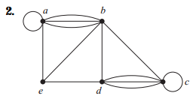

**A:**

Number of vertices = 5

Number of edges 13

deg(a) = 6

deg(b) = 6

deg(c) = 6

deg(d) = 5

deg(e) = 3

Isolated vertices = None

Pendant vertices = None

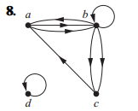

**A:**

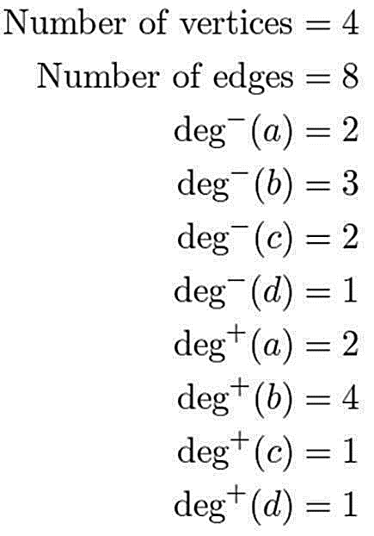

**10.3(P1)**

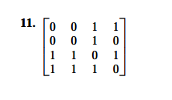

**A:**

The adjacency matrix is a 4x4-matrix; thus, the graph should have 4 vertices.

Let us call the vertices A, B, C, D.

Since a13 = 1,

there should be a directed edge from A to C.

Since a14 = 1, there should be a directed edge from A to D.

Since a23 = 1, there should be a directed edge from B to C.

Since a31 = 1, there should be a directed edge from C to A.

Since a32 = 1, there should be a directed edge from C to B.

Since a34 = 1, there should be a directed edge from C to D.

Since as = 1, there should be a directed edge from D to A.

Since a42 = 1, there should be a directed edge from D to B.

Since a43 = 1, there should be a directed edge from D to C.

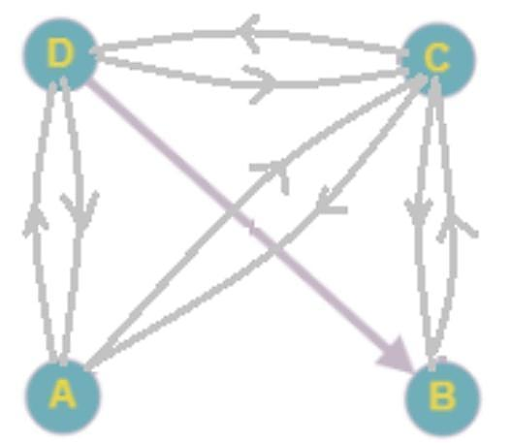

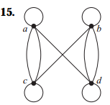

**Ans:**

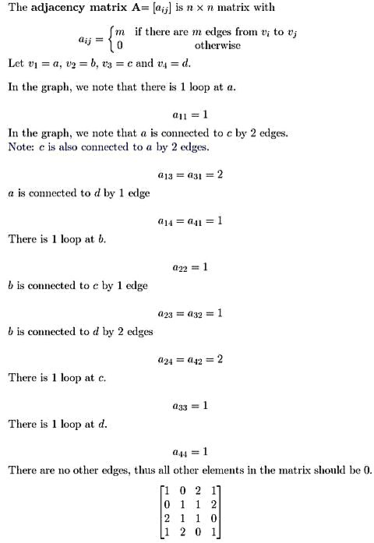

In Exercises 16–18 draw an undirected graph represented by the given adjacency matrix.

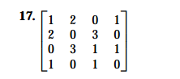

**Ans:**

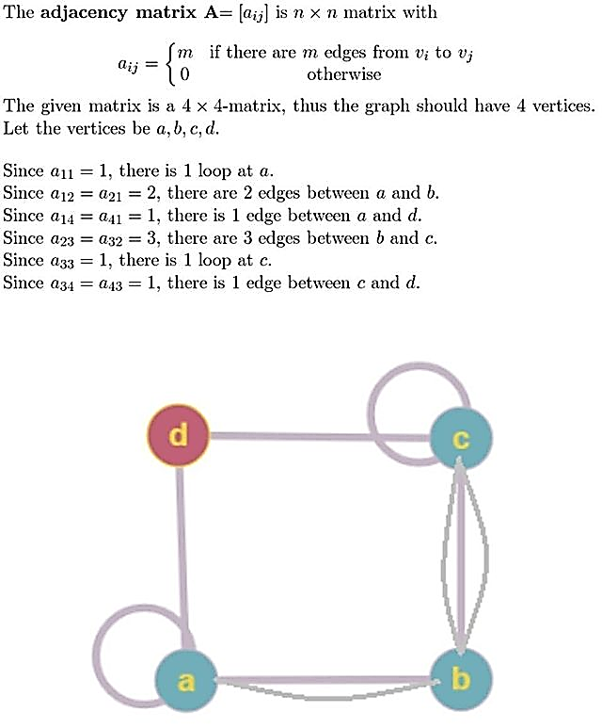



In Exercises 19–21 find the adjacency matrix of the given directed multigraph with respect to the vertices listed in alphabetic order

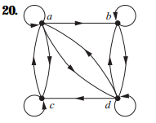

**Ans:**

26. Use an incidence matrix to represent the graphs in Exercises 1 and 2.  
**Ans:**

Ex-1:

Ex-2:

27. Use an incidence matrix to represent the graphs in Exercises 13–15

**A:**

